* 1. **MITS Altair 8800**

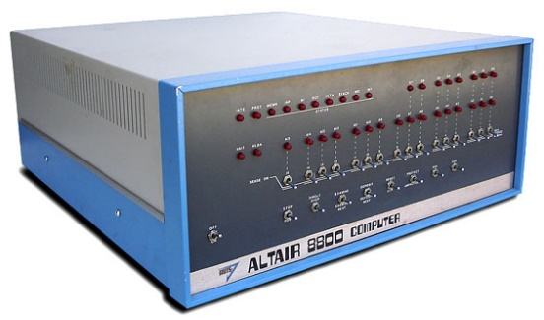

**Input/output –** switches is the output and inputs are the lights.

**Minimum/Maximum Ram (bits, kilobytes, and bytes) –** 256 bytes, 64K max

**What CPU did the computer has? -** Intel 8080, 2.0 MHz

* 1. **MOS KIM-1**

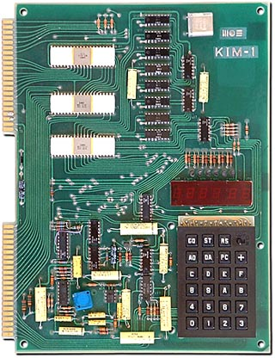 **Input/output –** for the input there are some sorts of shape (like a calculator) with a numerals and alphabets on the lower right hand side of the computer as shown in the picture below. The output is a horizontal rectangular shape above the numerals and alphabets, it’s the one with the red color. So, usually, they type the numerals or letters and it’s going to be displayed in the red screen. The input that these computer set into is the on-board hexadecimal keypad.

**Minimum/Maximum Ram (bits, kilobytes, and bytes) -** 1024 bytes

**What CPU did the computer has? -** MOS 6502, 1MHz

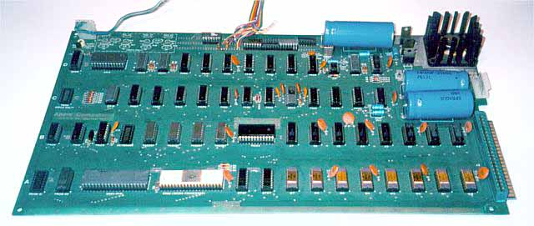

* 1. **Apple 1**

**Input/output –** composite video output keyboard interphase and 1 vertical expansion slots

**Minimum/Maximum Ram (bits, kilobytes, and bytes) -** 4K, 65K max

**What CPU did the computer has? -** MOS 6502, 1.0 MHz

* 1. **IBM Personal Computer (PC) 5150**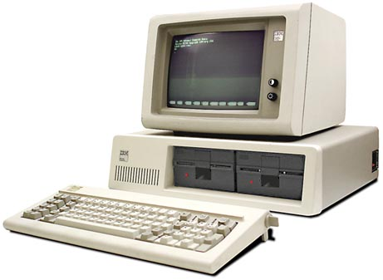

**Input/output –** This computer has a keyboard like a modern day today. So, typically, we type letters and numbers or words and that will be displayed in the screen on the computer and that is the output.

**Minimum/Maximum Ram (bits, kilobytes, and bytes) -** 16K, 640K max

**What CPU did the computer has? -** Intel 8088, 4.77MHz

* 1. 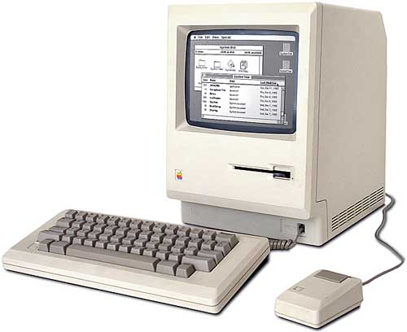**Apple Macintosh**

**Input/output –** The output is the keyboard that that’s there. This keyboard is also similar to the modern day keyboards. Using this keyboard, we could potentially write anything which is the input and it will be displayed in the computer screen whatever we wrote which is the output. The computer also has a spot where people can insert the CD’s on the lower right of the computer.

**Minimum/Maximum Ram (bits, kilobytes, and bytes) -** 128K, later 512K

**What CPU did the computer has? -** Motorola 68000, 7.83 Mhz

**2 Base Conversion**

**3 Explorations**